Final Project Report

Faculty Directory for Multi University



Project Supervisor
Saima Jamil

Submitted By

S21025A8D8

Moin Israr BC180404438

Software Projects & Research Section,
Department of Computer Sciences,
Virtual University of Pakistan


CERTIFICATE

This is to certify that Moin Israr (Bc180404438) has worked on and completed their Software Project at Software & Research Projects Section, Department of Computer Sciences, Virtual University of Pakistan in partial fulfillment of the requirement for the degree of BS in Computer Sciences under my guidance and supervision.

In our opinion, it is satisfactory and up to the mark and therefore fulfills the requirements of BS in Computer Sciences.

Supervisor / Internal Examiner

Saima Jamil,
Supervisor,
Software Projects & Research Section,
Department of Computer Sciences
Virtual University of Pakistan

___________________
(Signature)

External Examiner/Subject Specialist
<<External Supervisor Name>>

___________________
(Signature)

Accepted By:

_____________
(For office use)

EXORDIUM

In the name of Allah, the Compassionate, the Merciful.

Praise be to Allah, Lord of Creation,
The Compassionate, the Merciful,
King of Judgment-day!

You alone we worship, and to You alone we pray for help,
Guide us to the straight path

The path of those who You have favored,

Not of those who have incurred Your wrath,
Nor of those who have gone astray.

DEDICATION

ACKNOWLEDGEMENT
PREFACE
TABLE OF CONTENTS

CHAPTER NO. 1
gathering & Analyzing info 10

1.1 Introduction

1.2 purpose

1.3 scope

1.4 definitions, acronyms and abbreviations

1.5 Project requirements

1.5.1 Functional Requirements

1.5.2 Non-Functional Requirements

1.6 use cases and usage scenarios

1.6.1 Use Case Diagrams

1.6.2 Usage Scenarios

1.7 Development Methodology

1.7.1 Chosen Methodology

1.7.2 Reasons for Chosen Methodology
1.7.2 Work Plan (Gantt Chart)
1.7.2 Project Schedule (Submission Calendar)

CHAPTER NO. 2
designing the project 12

2.1 Introduction

2.2 purpose

2.3 scope

2.4 definitions, acronyms and abbreviations

2.5 Architectural Representation (Architecture Diagram)

2.6 Dynamic Model: Sequence Diagrams

2.7 Object Model/Logical Model: Class Diagram

2.8 Database Model (Database Diagram)

2.9 Graphical User Interfaces

Chapter no.3
DEvelopment 13
3.1 Development plan (Architecture Diagram)

<<Dear Students, you have to take special care of page numbers, which are written against each Chapter and SUBHEADINGS. You have to mention your own page numbers and correct one against each document heading. Make proper table of contents. Remember that if there are any new headings or you have included more headings in your documents then you also have to write these in table of contents and modify table of contents according to your documents material>>

CHAPTER 1
Gathering & Analyzing Info

  - Purpose

A platform for all students to learn efficiently and distantly by choosing one the best faculty all over the world teaching in different universities, in different departments in major of different courses. Through this platform, students can reach their desire faculty by searching by different categories, since this platform holds all the faculty details from major universities, all over the world.

  - Scope

In the time of Covid-19, many students face difficulties in learning due to the lack of the best faculty. Therefore, a large number of students tend to more towards the remote study and the first thing they do, is to find the best online faculty all over the world. The problem arises where they had to search through every university's website side by side in order to find the best faculty member.
"Faculty Directory for Multi Universities" is the solution to the above problem. The goal of this web application is to facilitate students through a user-friendly graphical user interface with the best faculty members so that they don't have to search every site instead they will find the world's best faculty member on this single platform so that they can search every faculty on this website accordingly.
On the main page, the visitor (user) will see the top faculty members list among all. Users will be able to search faculty details such as name, university, their department, their specialties, professional interest, etc. using different filters.
Faculty Members will have to register themselves in order to add their profile on this directory that will be allowed by the administrator so that visitors will see their profile.
The admin will be authorized to add and manage all the faculty details. Visitors will not need any registration in order to search faculty

  - Projects Requirements

    - Functional Requirements

- Faculty:

  - Registration and sign in: Faculty member will register him/herself in the directory and will be able to login after the approval of registration request by the Admin.
  - Add personal details: Faculty member will have the rights of adding, updating their personal detail in the profile.

- Admin

  - Approve Faculty Registration: Admin can approve the registration requests from faculty members.
  - Manage Faculty information: All the added faculty details can be Viewed / Updated / Deleted by the admin.

- Visitor/Student

  - Faculty List: All the added faculty details will be displayed to the user.
  - Refine / Search: User can search a specific faculty detail by different filters such as Name, University, Department, Courses, Area of Expertise, and Professional Interests etc.

    - Non- Functional Requirements

- Responsive/Performance:

  - Registration and sign in: Faculty member will register him/herself in the directory and will be able to login after the approval of registration request by the Admin.
  - Add personal details: Faculty member will have the rights of adding, updating their personal detail in the profile.

- Admin

  - Approve Faculty Registration: Admin can approve the registration requests from faculty members.
  - Manage Faculty information: All the added faculty details can be Viewed / Updated / Deleted by the admin.

- Visitor/Student

  - Faculty List: All the added faculty details will be displayed to the user.
Refine / Search: User can search a specific faculty detail by different filters such as Name, University, Department, Courses, Area of Expertise, and Professional Interests etc.

  - Use Cases & Usage Scenario

    - Use Case Diagram

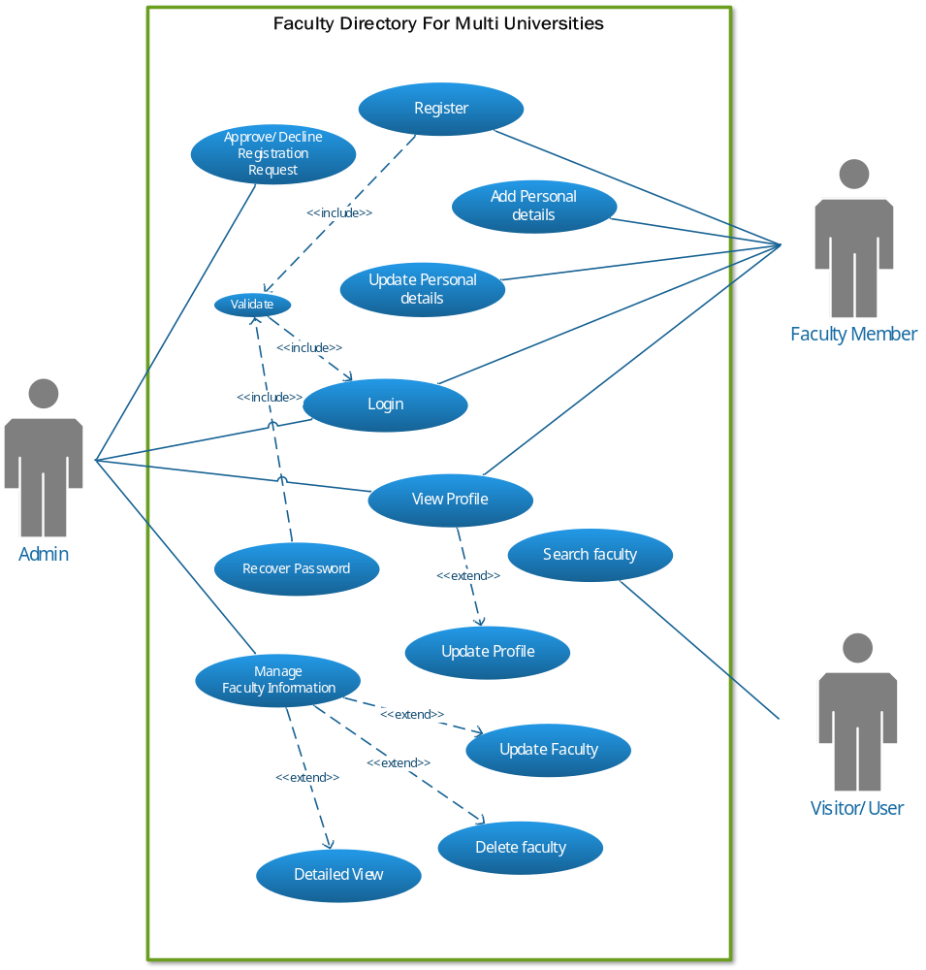

    - Usage Scenarios

Use Case Title | Login
Use Case Id | 1
Actions | Login to website
Descriptions | This Use Case will allow member to login into the site / system. They will have to enter his / her Email and Password to get login into the system
Alternative Paths | None
Pre-conditions | - System should be connected with the database  - Application should be running properly.  - User should have a Valid Username and Password.  - Faculty Member must have registered account in the application before login  - Faculty Member can sign in after the approval of admin
Post-conditions | - Member logged into the system successfully.  - Member re-directed to his / her profile, based on his / her role in the system.
Author | S21025A8D8 (BC180404438)
Exceptions | None

Use Case Title | Registration
Use Case Id | 2
Actions | Register to this website database
Descriptions | This Use Case will allow the only Users to make a registration to get facilities provided by this website. User will have to fill a form containing all the necessary information which is needed to complete the registration process.
Alternative Paths | None
Pre-conditions | - System should be connected with the database.  - Application should be running properly.  - User has a Valid Mobile / Email Address.
Post-conditions | - The Registration was successful.
Author | S21025A8D8 (BC180404438)
Exceptions | None
Use Case Title | View Profile
Use Case Id | 3
Actions | Members can view their Profile
Descriptions | This Use Case will allow members to see their profile after they logged in to the system. User will have to click the Profile button on the top of the website in their dashboard
Alternative Paths | None
Pre-conditions | - System should be connected with the database.  - Application should be running properly.  - Member must have logged in with their credentials
Post-conditions | - Members have to click the profile element
Author | S21025A8D8 (BC180404438)
Exceptions | None

Use Case Title | Update Profile
Use Case Id | 4
Actions | Members will edit the profile form showing in profile section
Descriptions | This Use Case will allow Member to edit their profile including their password. The Member will have to save the profile after editing. They must have to enter their previous password in order to change it.
Alternative Paths | None
Pre-conditions | - System should be connected with the database.  - Application should be running properly.  - Member must have logged in with their credentials
Post-conditions | - Profile Updated Successfully Popup will show up.
Author | S21025A8D8 (BC180404438)
Exceptions | None

Use Case Title | Approve/Decline Registration Request
Use Case Id | 5
Actions | Admin will accept/reject Faculty Member’s Registration request
Descriptions | This Use Case will allow admin to see the registrations request made by faculty member. The admin will decide whether to accept or reject the request by click button respectively.
Alternative Paths | None
Pre-conditions | - System should be connected with the database.  - Application should be running properly.  - Admin must have logged in with their credentials
Post-conditions | - The faculty member request will be accepted/declined accordingly
Author | S21025A8D8 (BC180404438)
Exceptions | None

Use Case Title | Manage Faculty Information
Use Case Id | 6
Actions | Admin can view, update, delete faculty information that was added by the faculty member
Descriptions | This Use Case will allow admin to view the faculty information as well as admin can update them and can delete them accordingly. All faculty members details will be shown in admin dashboard
Alternative Paths | None
Pre-conditions | - System should be connected with the database.  - Application should be running properly.  - Admin must have logged in with their credentials  - There must be at least one faculty member’s info
Post-conditions | - Details will be update, delete accordingly
Author | S21025A8D8 (BC180404438)
Exceptions | None

Use Case Title | Add Personal details
Use Case Id | 7
Actions | Faculty Member will add their personal details through the form that will show up in their profile
Descriptions | After the approval of admin, Faculty Member will add their personal information that will be shown up in the website that will be viewed by visitor/student. When faculty member will log in to the system. They will redirect to their dashboard where they can add.
Alternative Paths | None
Pre-conditions | - System should be connected with the database.  - Application should be running properly.  - Member must have logged in with their credentials
Post-conditions | - Information will be added successfully
Author | S21025A8D8 (BC180404438)
Exceptions | None

Use Case Title | Update Personal Details
Use Case Id | 8
Actions | Faculty Member will update their personal details after adding through the form that will show up in their profile
Descriptions | After adding their personal details, Members can edit them accordingly through same form that was used to add
Alternative Paths | None
Pre-conditions | - System should be connected with the database.  - Application should be running properly.  - Member must have logged in with their credentials  - They must have to add their details first in order to update
Post-conditions | - Information will be updated successfully
Author | S21025A8D8 (BC180404438)
Exceptions | None

Use Case Title | Search Faculty
Use Case Id | 9
Actions | Visitor will see faculty details on website using different filters
Descriptions | This Use Case will allow the visitor to search for the faculty Member’s information that has been added into the website by Faculty Member. Visitor can search the faculty using different filters such as by their name, majors, department etc.
Alternative Paths | None
Pre-conditions | - System should be connected with the database.  - Application should be running properly.  - There must be at least One Faculty Member’s info
Post-conditions | - Visitor has searched the Faculty successfully
Author | S21025A8D8 (BC180404438)
Exceptions | None

Use Case Title | Recover Password
Use Case Id | 10
Actions | Member can recover the password if they forgot
Descriptions | This Use Case will allow the Members to reset their password if they forgot it by using their registered email
Alternative Paths | None
Pre-conditions | - System should be connected with the database.  - Application should be running properly.  - Member must have valid email
Post-conditions | - Members has recovered password successfully.
Author | S21025A8D8 (BC180404438)
Exceptions | None

  - Development Methodology

    - Chosen Methodology

According to the requirement, for making our software we adopted the methodology “VU process model”. The description of which is given below:
- VU Process Model:
It is the combination of waterfall methodology and spiral methodology. It is also known as hybrid approach of system development. It has five phases, and which are Gathering and Analyzing requirement, Planning, Analysis and Design, Development and Final report.
Essentially, Water Fall Model is a framework for software development in which development proceeds sequentially through a series of phases, starting with system requirements analysis and leading up to product release and maintenance, whereas the key characteristic of spiral model is risk management at regular stages in the entire software development cycle.

- Diagram
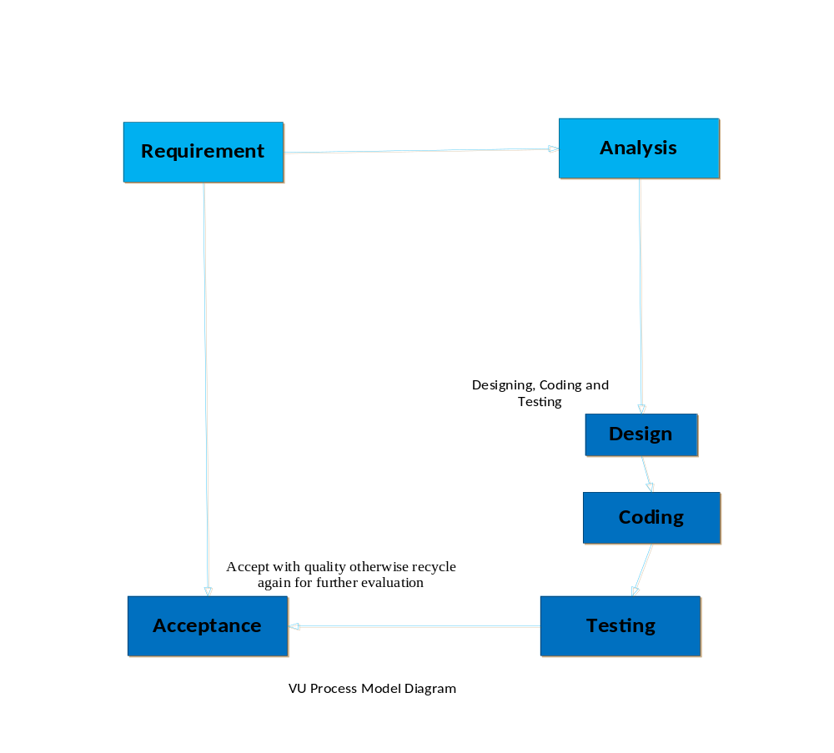
    - Reason for Chosen Methodology

Following are the basic reasons for choosing VU Process Model for our project:
- Our project is divided into different phases which we have to complete in sequence and submit it to our supervisor. In the requirement phase the system goals, services and constrains are established after discussion with user.
- The planning phase is synchronized effort to find all the potential roadblocks and draft a robust plan to tackle each. This phase usually involves a lot of brainstorming within software development team as well as with respective client. It maximizes the quality of system and minimizes any risks and errors.
- If Supervisor suggests improvement, then we will make improvement in planning phase. This process will be adopted due to the spiral nature of VU Process model. When the phase is well-improved and well worked out, and accepted by our supervisor then we will proceed to next phase. This will be done due to the waterfall nature of the VU Process model.

Hence both models are suppressed in single form and that will be our VU process model. It will provide error free result as each step is done in a sequence.

    - Work Plan (Gantt Char)

          - TimeLine

Start
May 21, 2021
Finish
October 4, 2021
June
July
August
September
October
Software Requirements & Specifications (SRS)
May 21, 2021 - June 15, 2021
Design
June 16, 2021 - July 15, 2021
Test Phase
July 16, 2021 - August 2, 2021
Final Deliverable
August 3, 2021 - October 4, 2021
Today

          - Gantt Chart

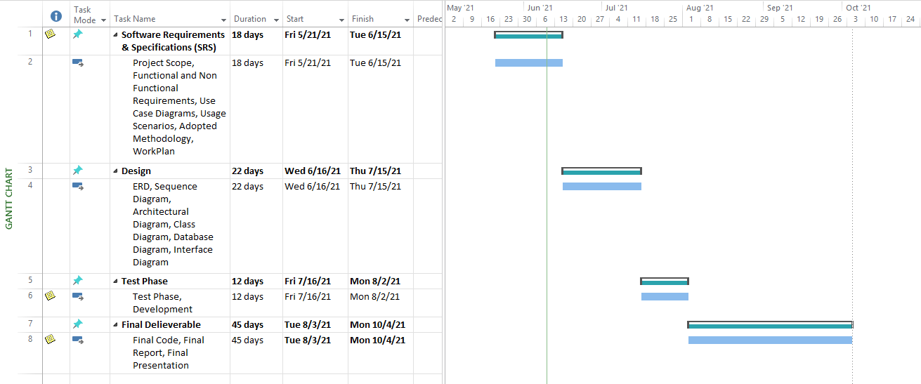

CHAPTER 2
Designing the Project

CHAPTER 3
Development

REFERENCES

APPENDIX

